Original table:
..The main source table where data is first stored.
Cloned table:
.. A copy created instantly using zero-copy cloning
Assignment 1: Base Table Analysis
- Load both datasets into Snowflake tables
Employee table:
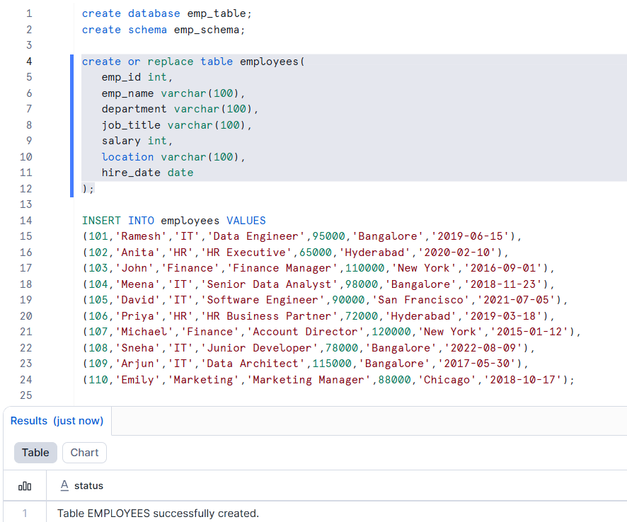
Department table:
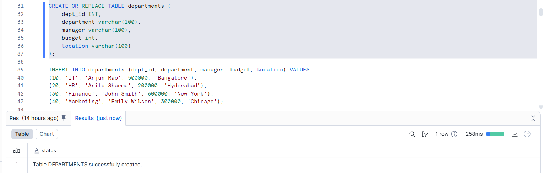

- Validate row counts and data distribution
Employee table:
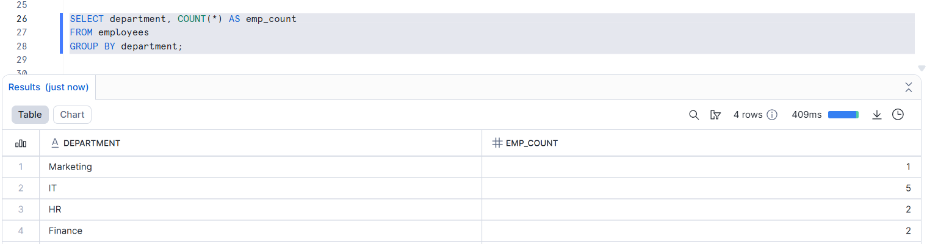
Department table:
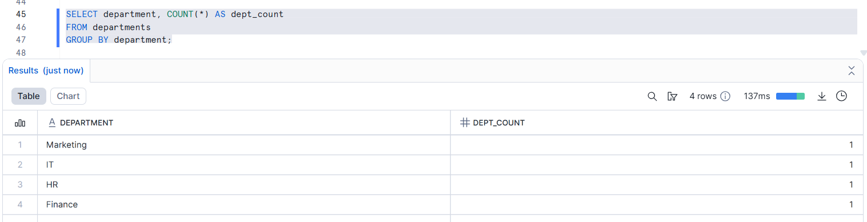
- Identify candidate tables for cloning
Candidate Tables - source table
1.Employees 2.Departments

- Explain why these tables are suitable for cloning experiments

- Small and manageable size
Both employees and departments tables have a limited number of rows, making them ideal for quick cloning and easy observation of changes.
- Stable base data
The data does not change frequently, which is perfect for testing clone behavior without constant data modifications.
- Well-structured schema
Clearly defined columns (IDs, names, departments, locations) help in easily validating cloned data.
- No complex transformations
These are base tables (not views or CTAS outputs), fully aligned with the rule of using only cloning.
- Ideal for zero-copy cloning demonstration
Snowflake clones share underlying storage initially, allowing students to observe how storage is saved until DML operations occur.

Assignment 2: Table-Level Cloning
- Clone the employee table
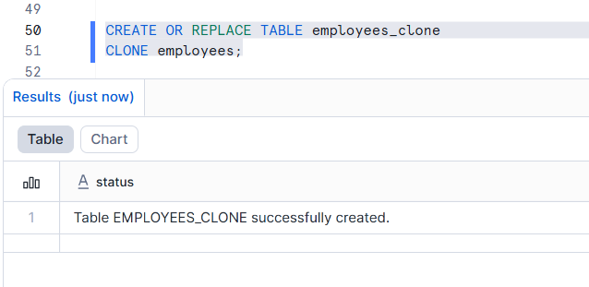
- Compare:
  - Row count : Between clone and original
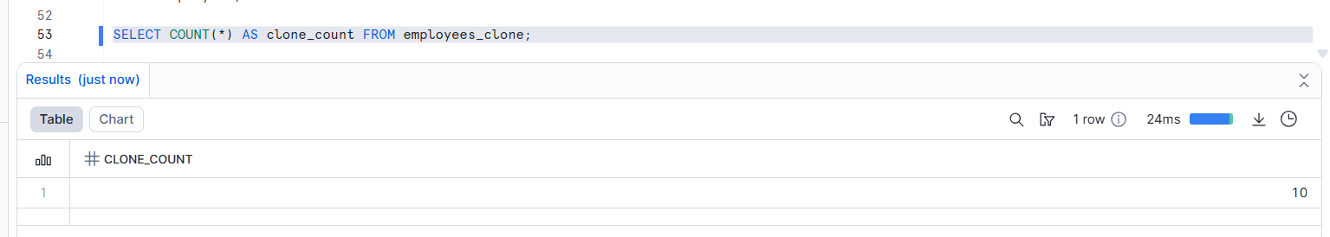
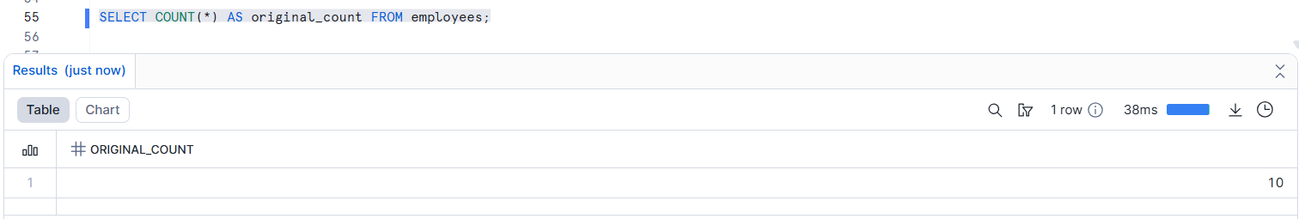
...Both tables return 10 rows
…Confirms data consistency between original and clone

  - Query performance:
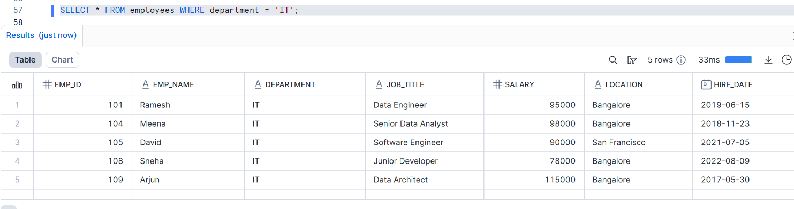
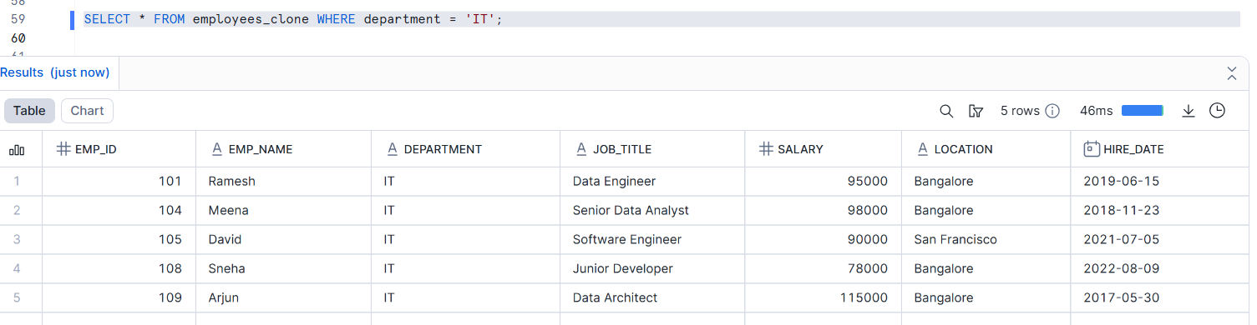
..Query execution time is nearly identical
..Clone uses the same underlying micro-partitions as the original table
  - Storage usage:
- BYTES shows how much physical storage the table is using
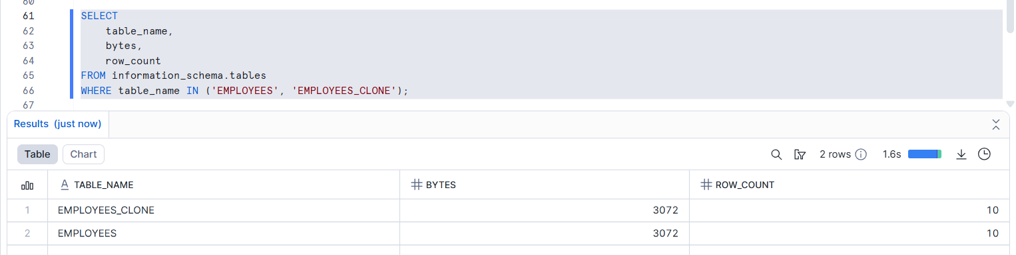

- Explain why clone creation is instantaneous
..Snowflake uses zero-copy cloning
..No physical data is copied during clone creation
..Only metadata pointers are created

Assignment 3: Change Isolation Testing
.…Checking that changes made in one table do NOT affect another table
- Update salary data in the original employee table
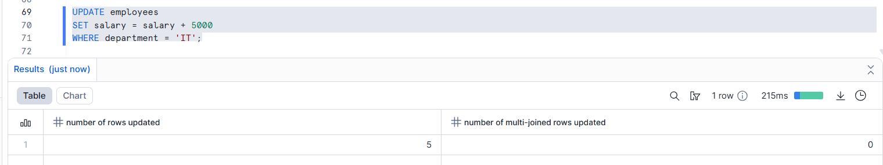
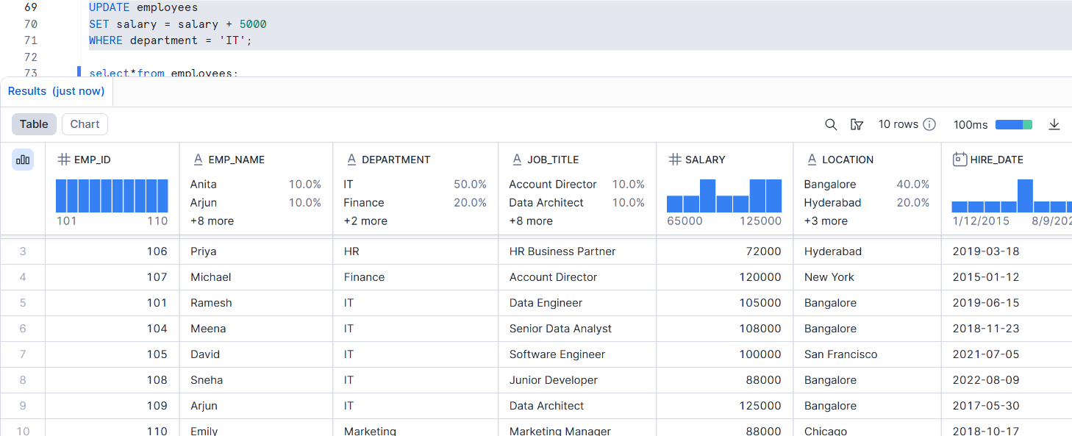
- Delete records in the cloned table
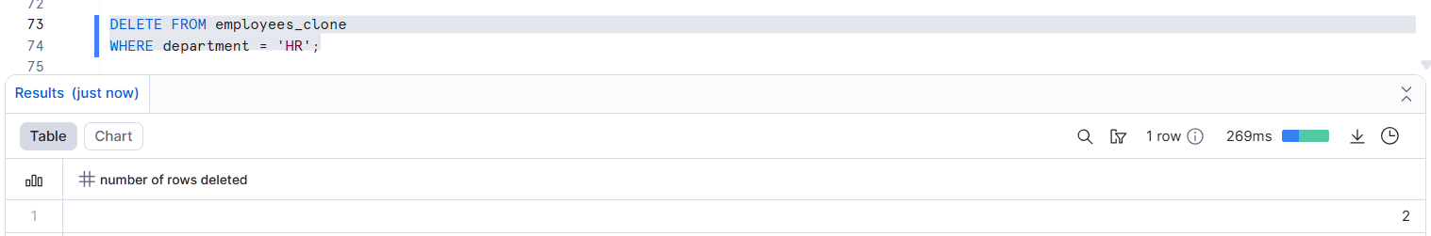
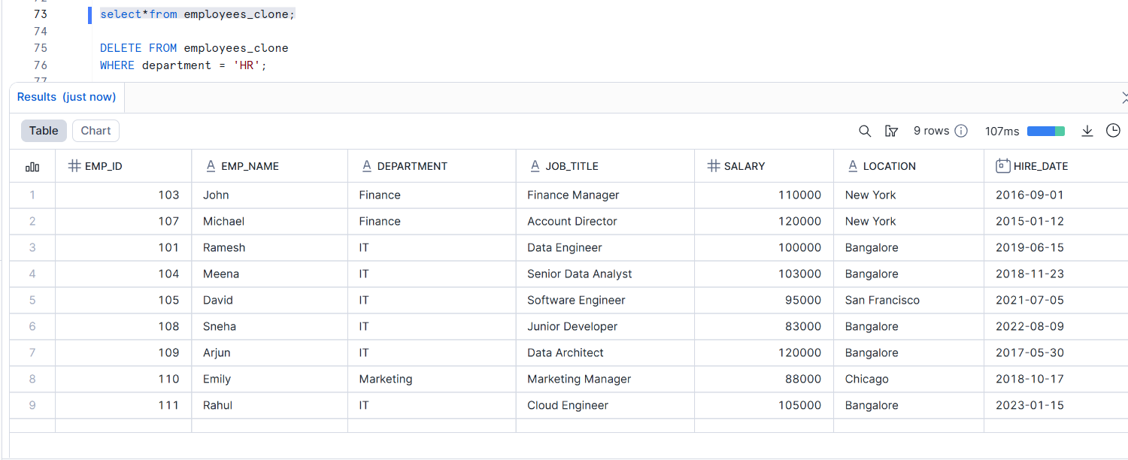

- Insert new records in the clone
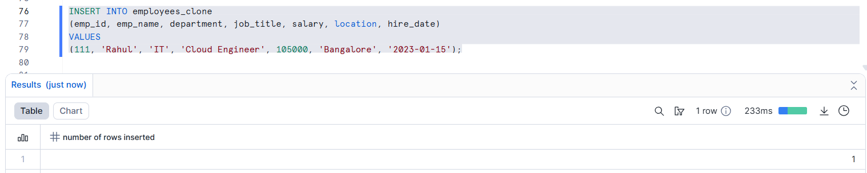
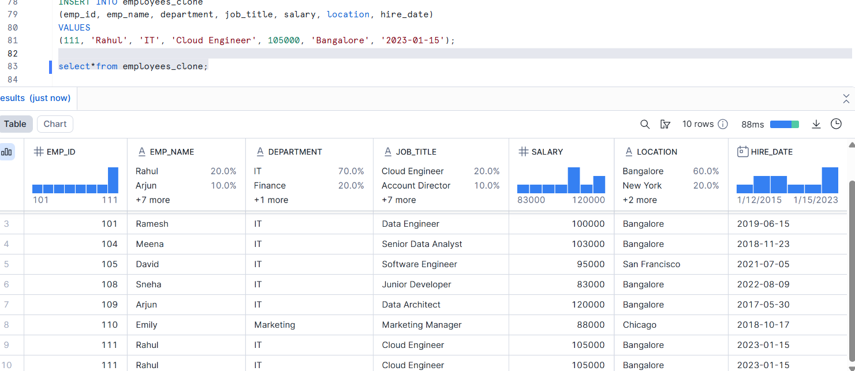
- Validate isolation between original and clone
Original table:
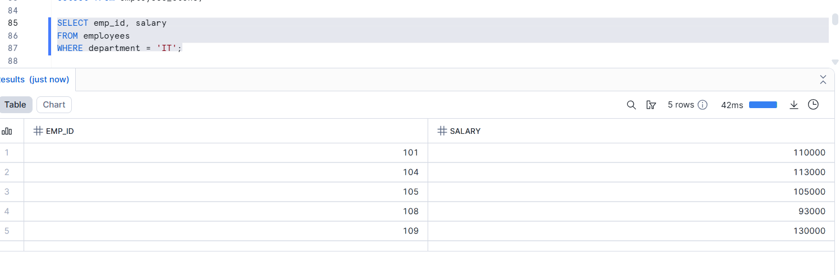
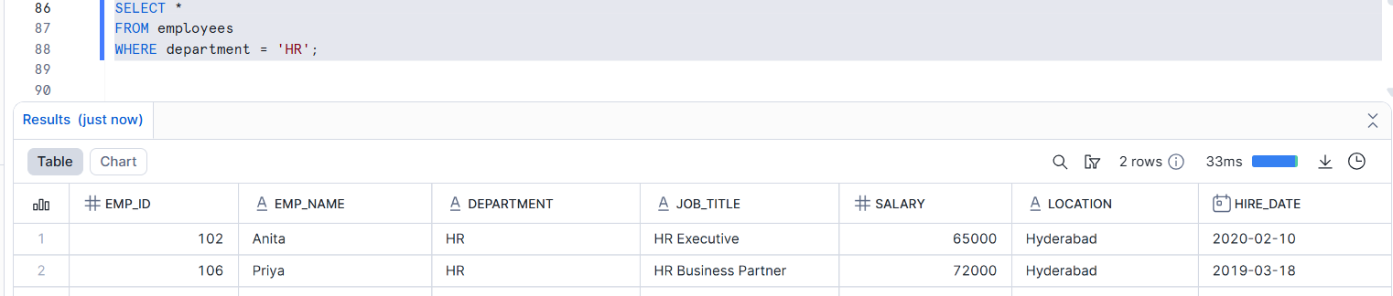
Clone table:
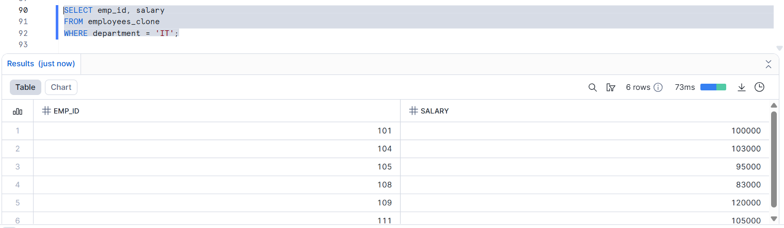

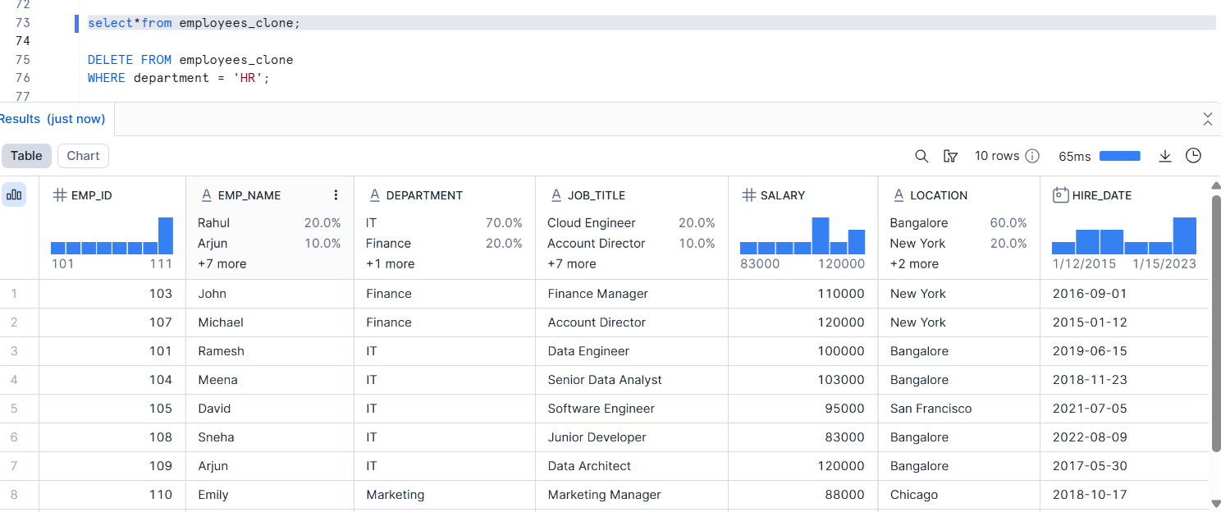

- Update data in the original table → clone data remains unchanged
- Insert or delete data in the clone → original table remains unchanged
- Both tables show different results after changes

- Explain backend copy-on-write behavior
Copy-on-write means Snowflake copies data only when changes happen, not when the clone is created
- Original table and clone initially share the same data
- No data is copied at clone creation
- When a row is updated, deleted, or inserted:
Snowflake creates a new copy only for the changed data
- Unchanged data remains shared
- This ensures data isolation with minimal storage usage

Assignment 4: Storage Growth Exploration
Storage Growth Exploration means checking when and why storage increases while working with cloned tables.
- Perform DML operations incrementally
Meaning:
Do data changes one by one, not all at once.
Example:
- First do UPDATE
- Then check storage
- Then do INSERT
- Then check storage again
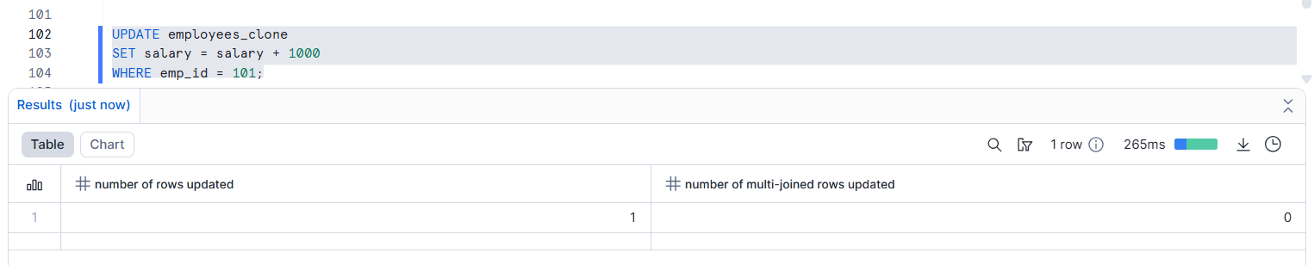
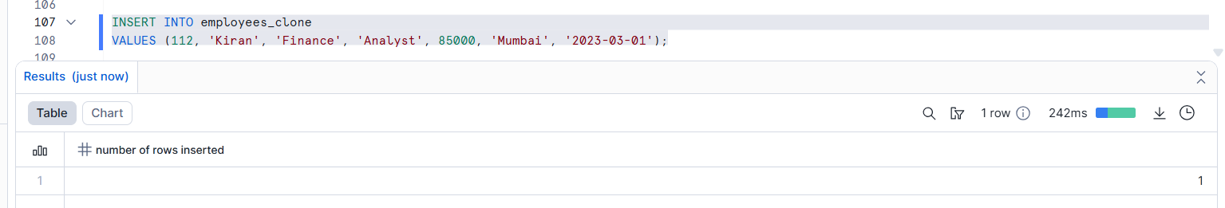
Final Output:
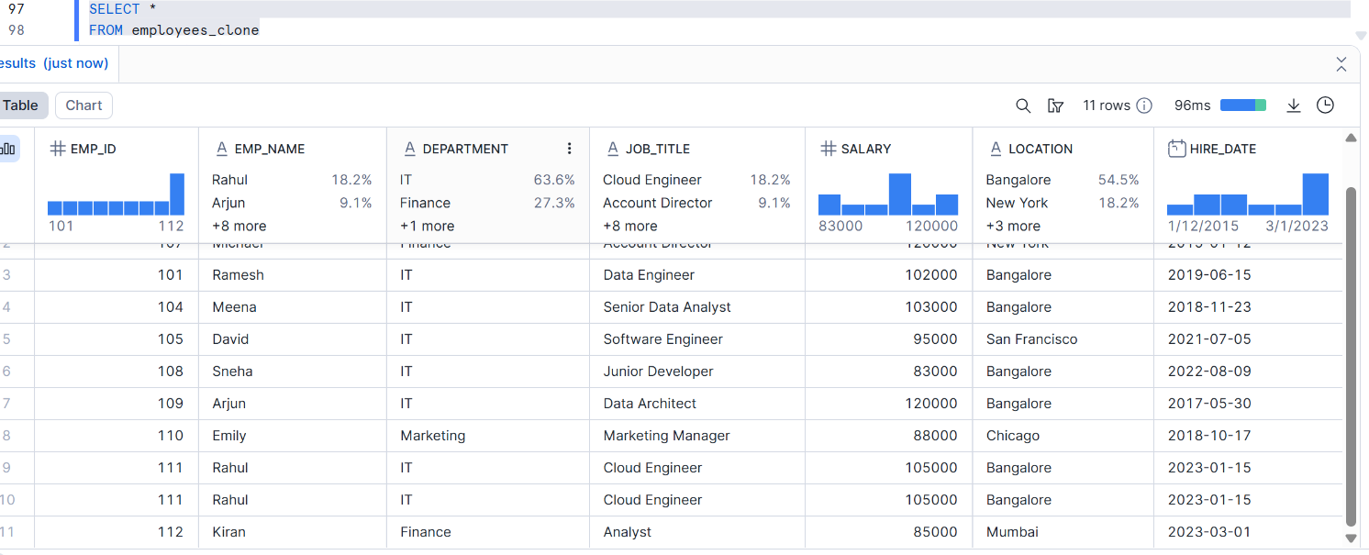

- Track storage before and after each operation
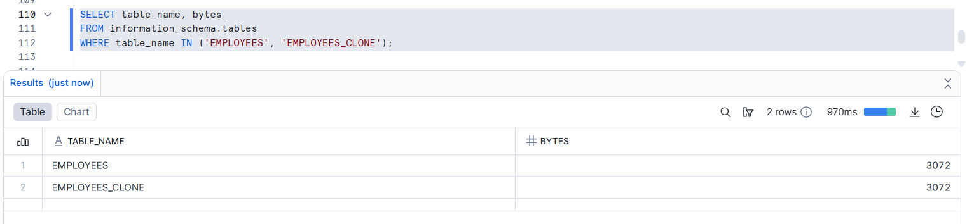
Before any DML (UPDATE / INSERT / DELETE):
Check storage → no increase
After UPDATE:
Check storage again → storage increases slightly
After INSERT:
Check storage again → storage increases more
- Identify the exact moment storage increases
Storage increases at the moment when a DML operation is executed
(UPDATE, INSERT, or DELETE).
- Creating a clone → no storage increase
- Running SELECT queries → no storage increase
- First UPDATE / INSERT / DELETE → storage increases

- Explain Snowflake’s physical storage strategy

- Snowflake stores data in small read-only blocks called micro-partitions
- These micro-partitions are compressed and optimized automatically
- When a table is cloned, data is shared, not copied
- Data blocks are never changed directly
- When data is updated, inserted, or deleted:
..Snowflake creates new micro-partitions for the changed data
..Old micro-partitions remain unchanged
- This method is called copy-on-write

Assignment 5: Time Travel Cloning
- Perform multiple updates on the original table
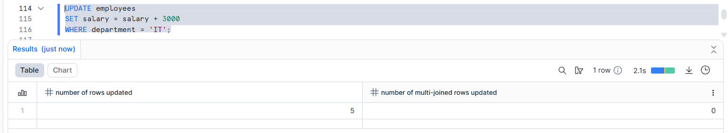
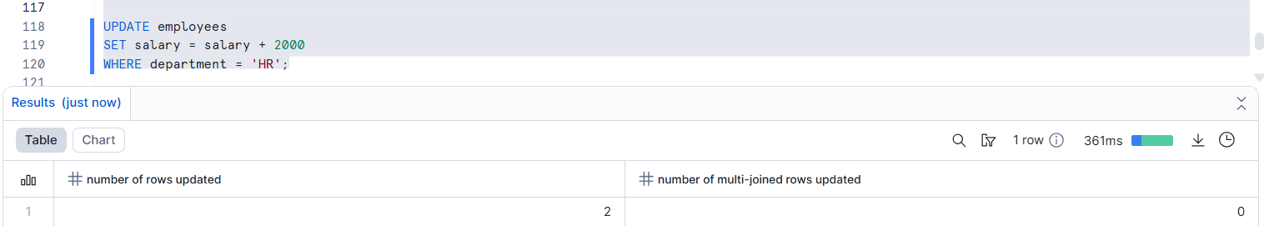
Final Output:
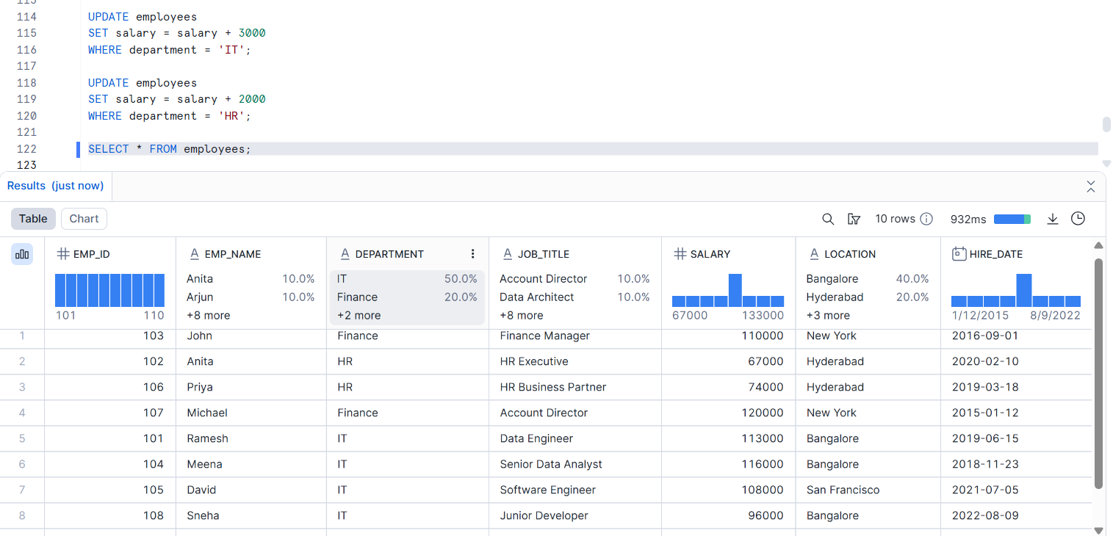
- Create clones from:
  - Current state
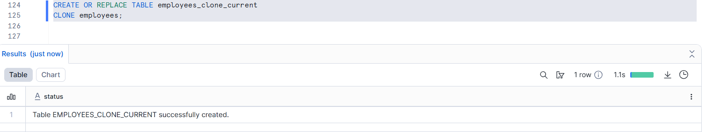

  - Past state (Time Travel)
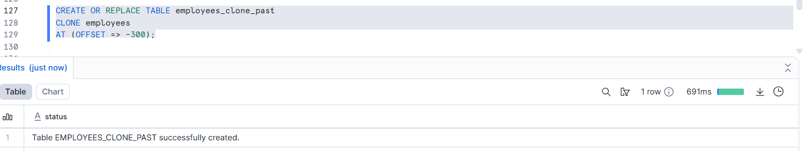
- Compare data across versions
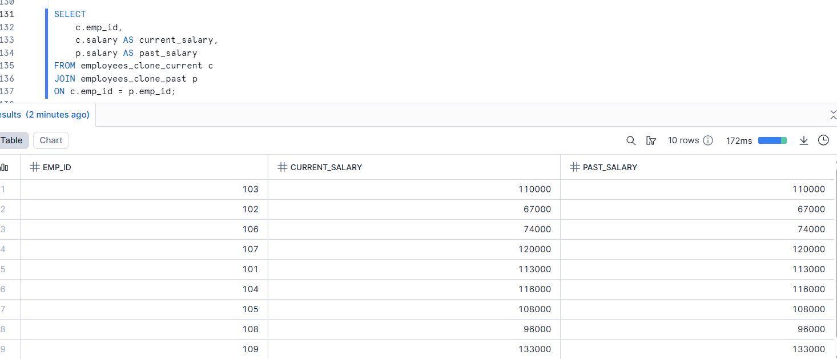

- Explain real-world recovery use cases

- Recover data after accidental UPDATE or DELETE
- Restore a table to a previous correct version
- Compare data before and after a mistake
- Quickly fix production issues without reloading data
- Support audit and investigation needs

Assignment 6: Schema-Level Cloning
- Clone a schema containing employee and department tables
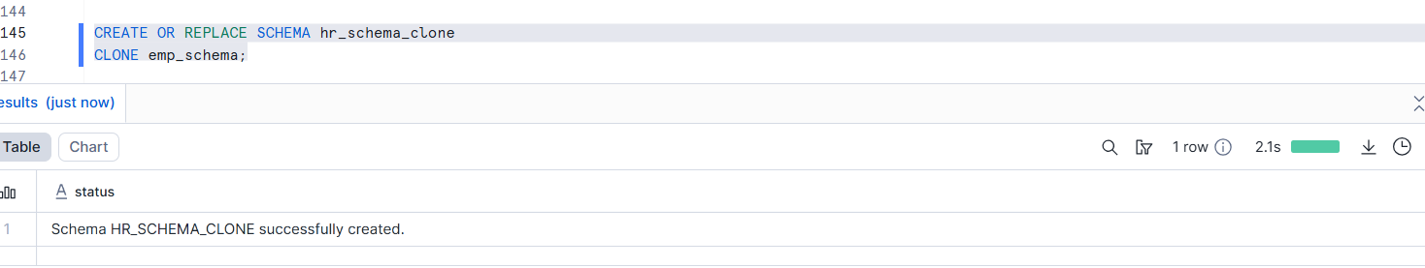
- Modify tables in cloned schema
Employee table:
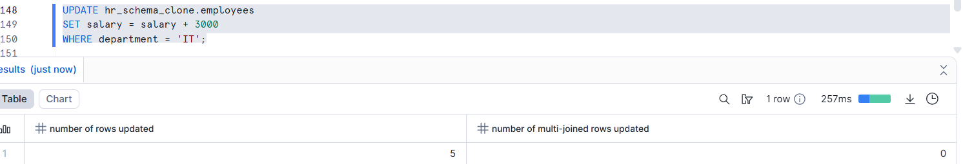
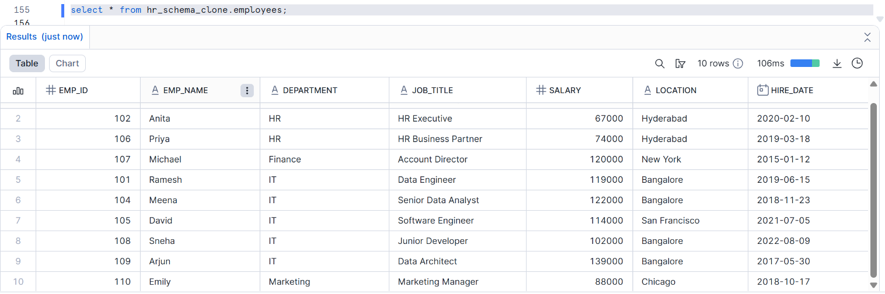
Department table:
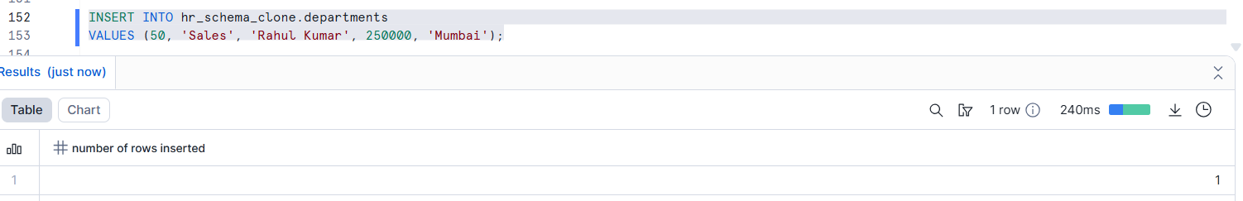
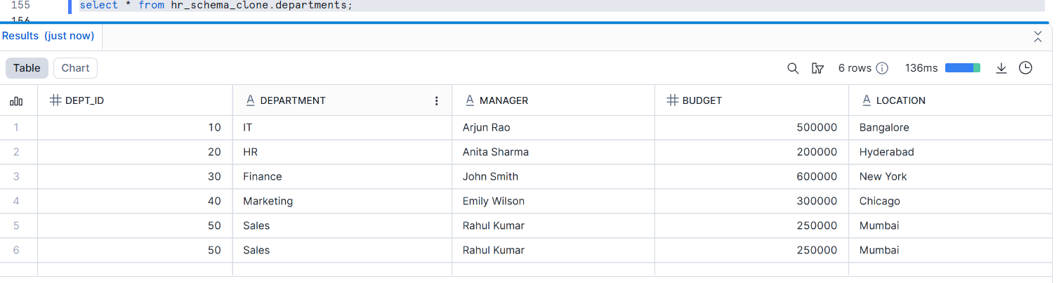
- Drop tables in original schema
Departments table:
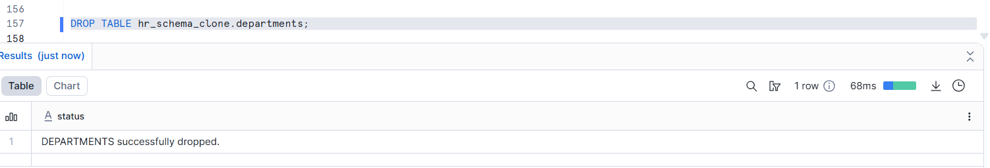
Employees table:
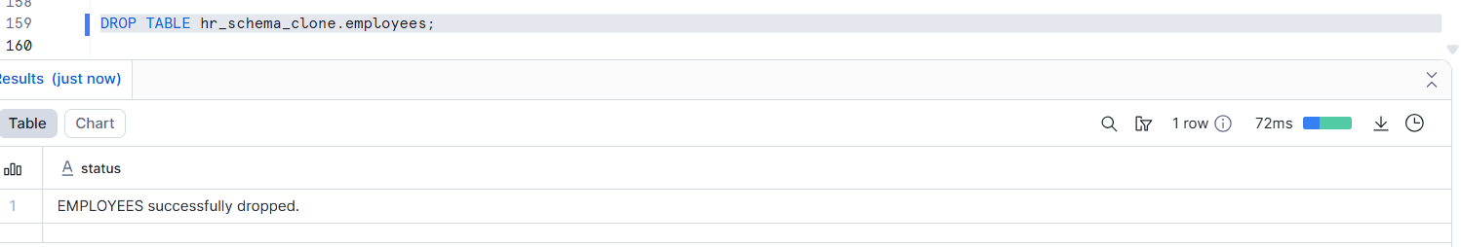
- Observe behavior and explain metadata inheritance
Metadata inheritance means the clone gets its own metadata while sharing data blocks until changes occur.
Observed behavior:
- Changes made in the cloned schema do not affect the original schema
- Dropping tables in the original schema does not delete tables in the clone
- Both schemas work independently
Metadata inheritance (meaning):
- When a schema is cloned, Snowflake copies metadata only, not the actual data
- Both schemas initially point to the same underlying data blocks
- Each schema has its own metadata
- Any change creates new data using copy-on-write

Assignment 7: Database-Level Cloning
- Clone the entire database
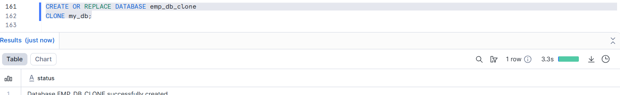
- Test query access and object availability
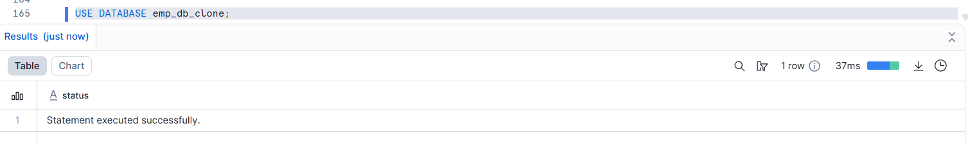
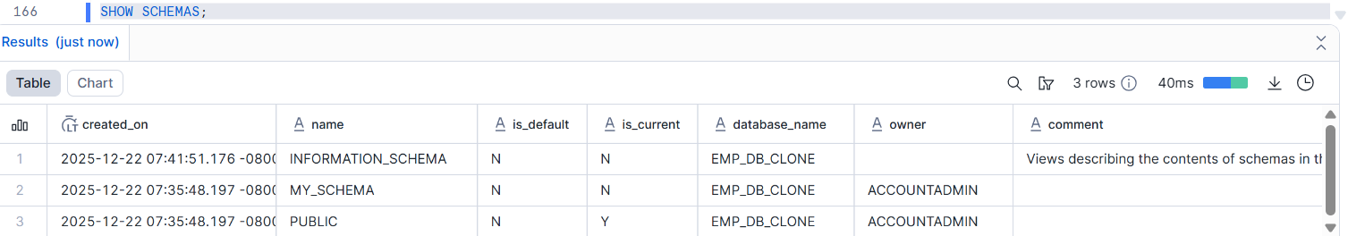
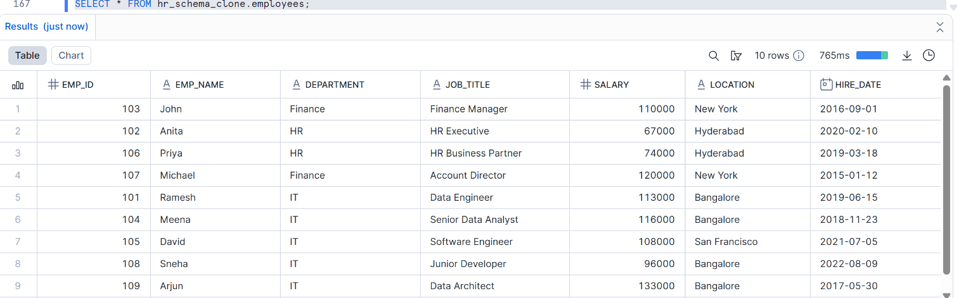
- All schemas and tables are available
- Data can be queried normally

- Perform DML on cloned database
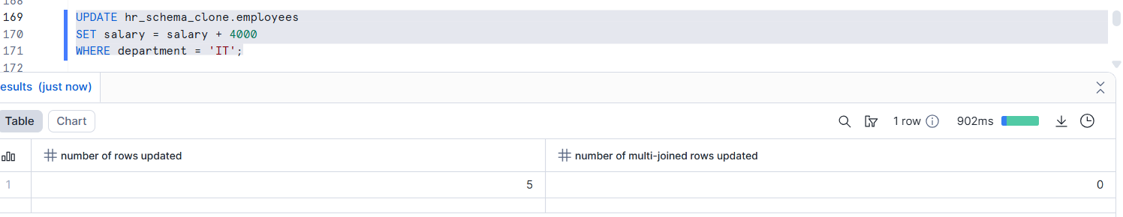
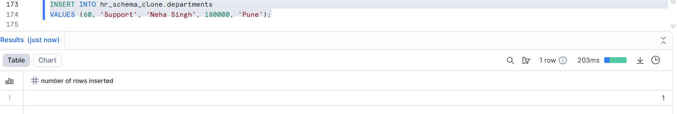
- Changes apply only to the cloned database
- Original database remains unchanged

- Explain how Snowflake isolates environments (Dev/Test/Prod)\

- Snowflake uses zero-copy database cloning
- Dev, Test, and Prod databases start by sharing the same data
- Each environment has independent metadata
- Changes in Dev/Test do not affect Prod
- New data is created only when changes happen (copy-on-write)

Assignment 9: Performance Comparison
- Run identical analytical queries on:
  - Original tables
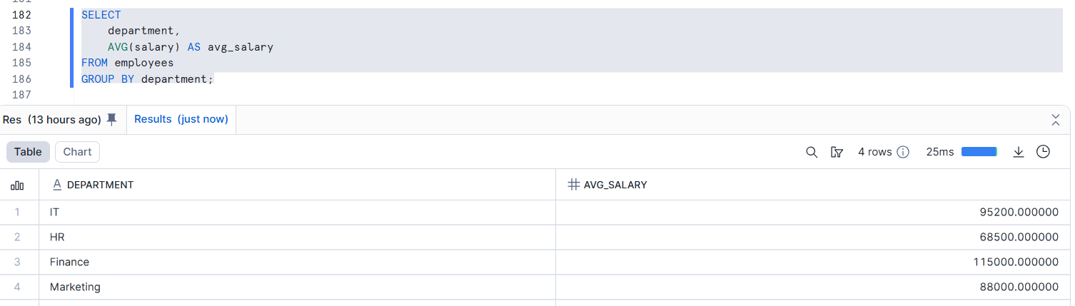
  - Cloned tables
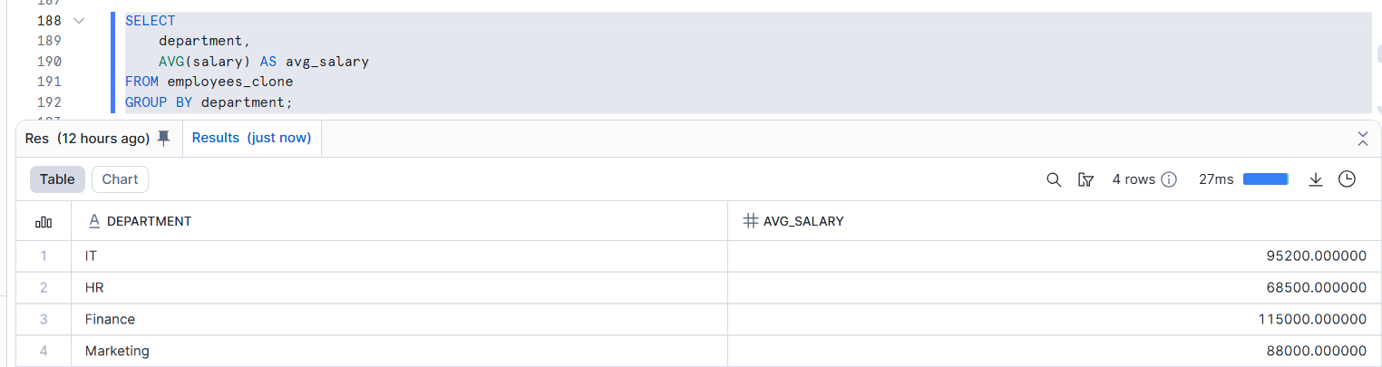
Both queries return the same result.
- Compare execution plans
Explain using text - we can identify the query performance.
Original table:
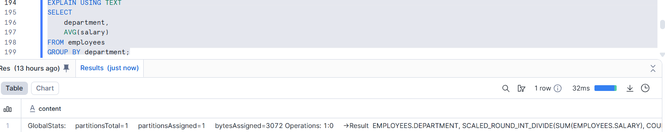
Clone table:
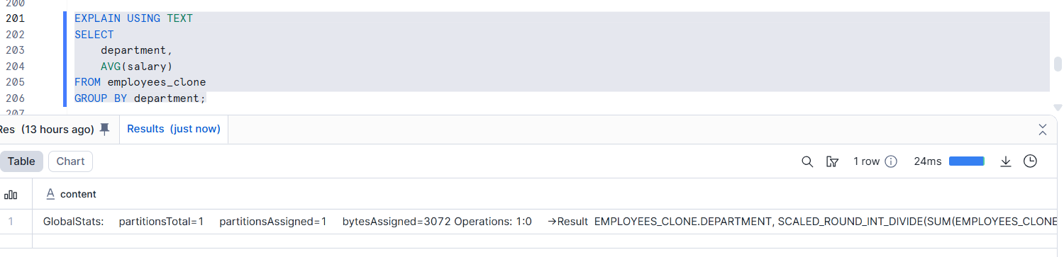
- Execution plans are nearly identical
- Same micro-partitions are scanned
- Same query optimization is applied

3. Explain performance similarities/differences
Performance is almost the same because original and cloned tables share the same data and execution plan; differences appear only after data changes or cache effects.

Assignment 10: Cleanup & Retention

- Drop original objects
Employees:
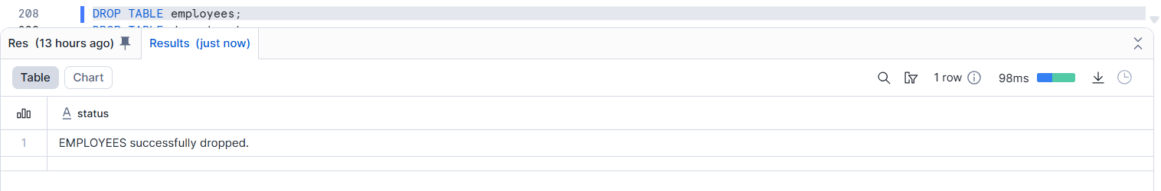Departments:
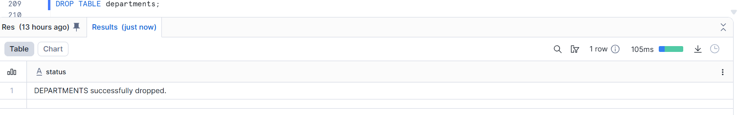

- Validate cloned object availability
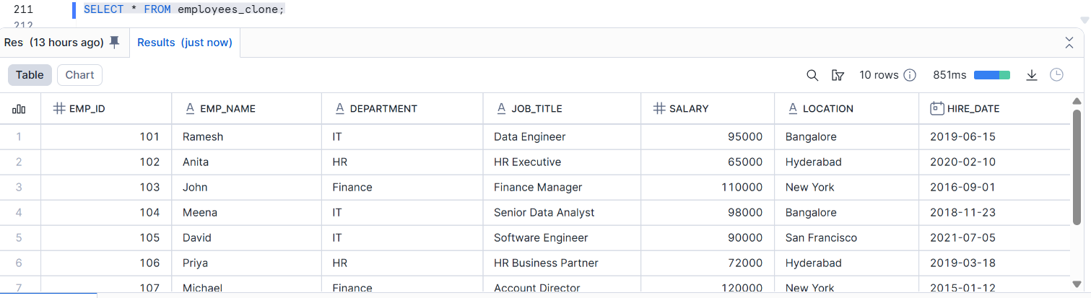
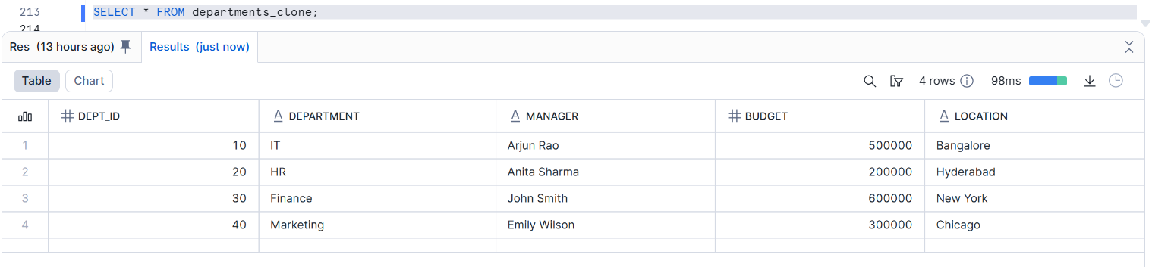

- Drop clone and analyze Time Travel behavior
Drop employees_clone / By using time travel the data is available.After retention period ends, data is permanently removed:
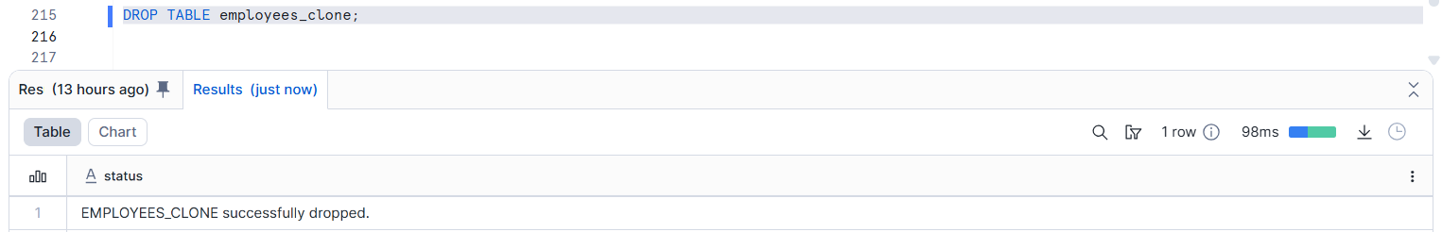
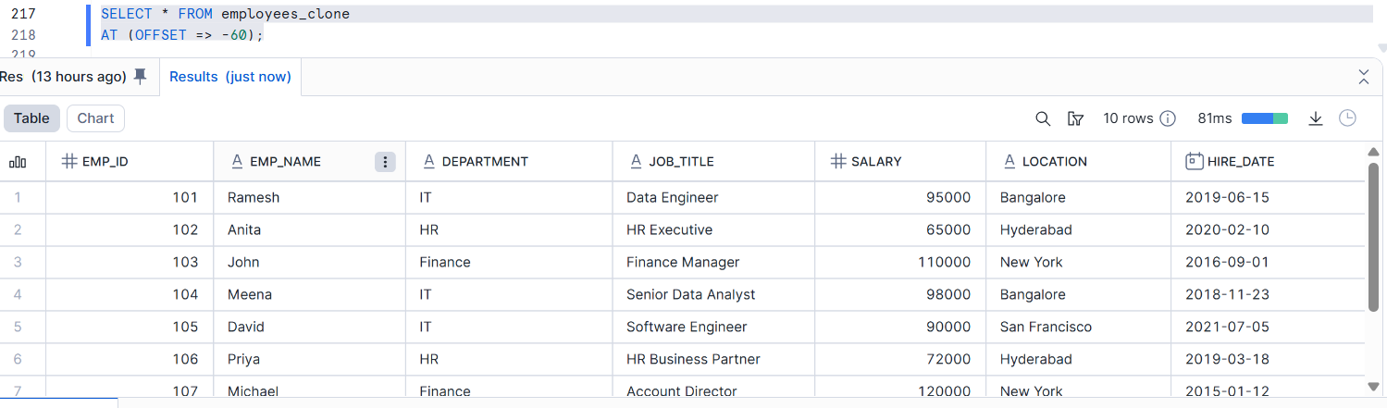

- Explain lifecycle and retention rules

- Dropped objects go into Time Travel
- Data can be recovered within retention period
- After Time Travel → data moves to Fail-safe
- After Fail-safe → data is permanently deleted
- Retention period depends on Snowflake edition

